**Class code:**

select * from Employees;

select distinct LastName, FirstName from Employees;

Select distinct Title from Employees;

Select t.TerritoryDescription,count(*) as EmployeeCount

from Territories t

join EmployeeTerritories et on t.TerritoryID=et.TerritoryID

group by t.TerritoryDescription

order by EmployeeCount desc

1. **List the customer contact names and titles sorted by company name.**

**SQL:**

select ContactName, ContactTitle from Customers

order by CompanyName desc

**Output:**

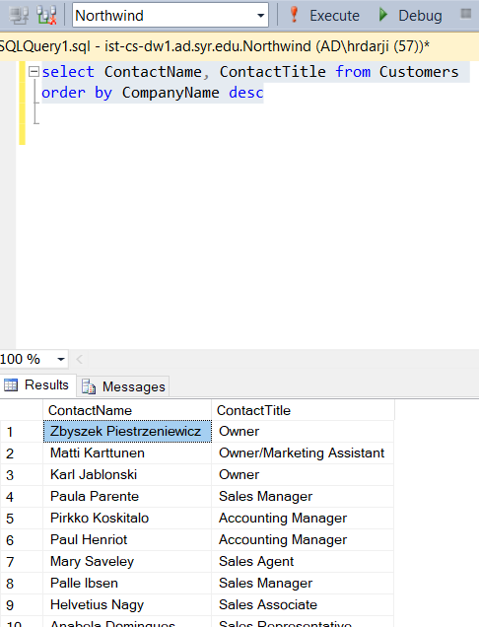

1. **Factoring in discounts, what is total amount of product sold?**

**SQL:**

Select SUM((UnitPrice*Quantity)-(Quantity*Discount)) as Total_Amount

from [Order Details]

**Output:**

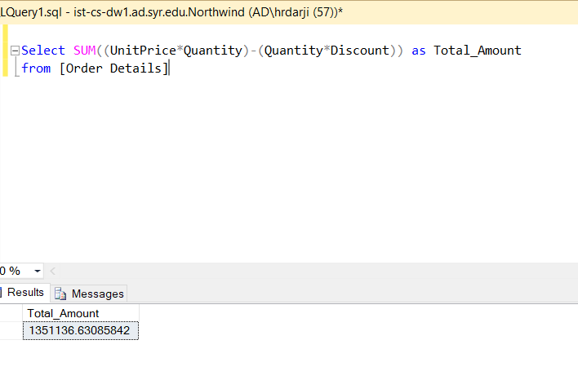

1. **Provide a list of product category names with counts of products in each category.**

**SQL:**

select * from Products

select c.CategoryName,count(p.ProductName) as product_count

from Products p inner join Categories c on p.CategoryID=c.CategoryID

group by c.CategoryName

select * from orders

**Output:**

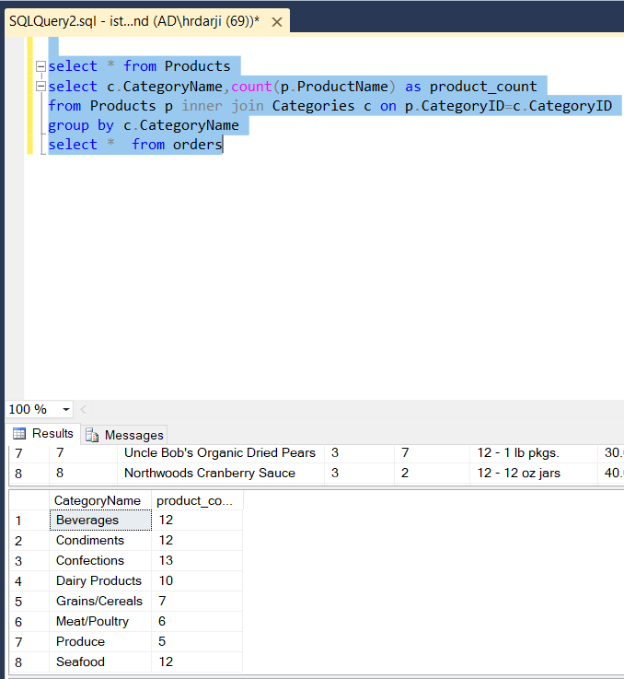

1. **Select a specific customer and display that customer’s orders with total amount of product sold for each order.**

**SQL:**

Select [Order Details].OrderID,[Order Details].Quantity from [Order Details]

join Orders on [Order Details].OrderID = Orders.OrderID

where Orders.CustomerID='ALFKI'

**Output:**

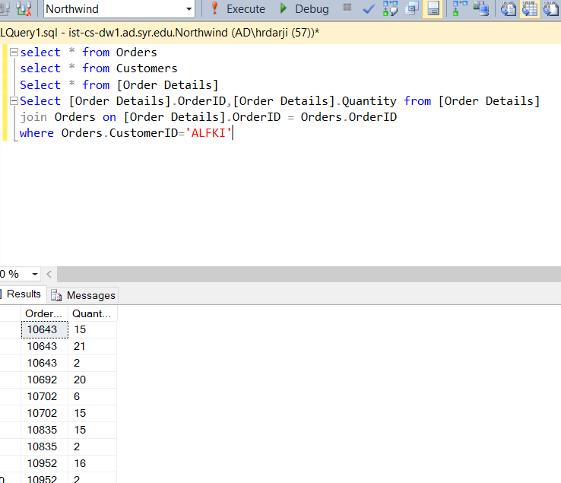

1. **Select a specific employee and each order, how it was shipped (shipvia) company who shipped it, and the total number of days elapsed from order date to shipped date.**

**SQL:**

Select OrderID,ShipVia,ShipName,DATEDIFF(d,OrderDate,ShippedDate) as ElapsedDate

from Orders

Where EmployeeID=5

**Output:**

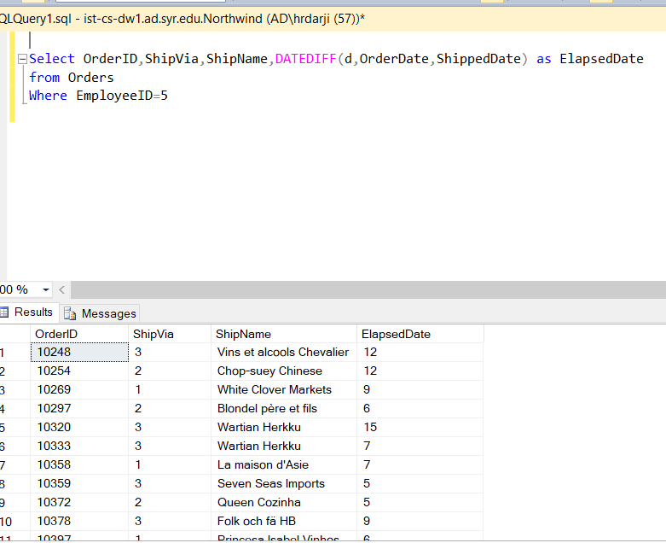

Table:

|  |  |  |  |  |
| --- | --- | --- | --- | --- |
| **Table** | **Type** | **Row Count** | **Business Key** | **One Row Is** |
| Employees | Master Data | 9 | None (PK used) | An Employee |
| EmployeeTerritories | Business Process | 49 | None (PK used) | An Employee assigned to a territory. |
| Customers | Master Data | 91 | CustomerID | A Customer |
| Suppliers | Master Data | 29 | None (PK used) | A Supplier |
| Products | Master Data | 77 | None (PK used) | A Product |
| Shipments (of Orders) | Business Process | 3 | None (PK used) | Shipment of an order |
| Details (of an Order) | Business Process | 2155 | OrderID, ProductID | Details of an order |